Murramarang Community Garden

Treasurers Report AGM
Saturday 10 September 2022
Year to Date Financial Status
Our bank balance for 2022 as at 26th August, 2022:
Opening | $8,807
Closing | $10,773

Details of the current financial situation can be found in Appendix 1.
Income and Expenditure
Our income for this year ($9,727) has included the following:
Donations | $103
Garlic Sales | $648
Grants | $5,500
Jams & Pickles | $54
Membership Fees | $530
Murramarang Markets | $995
Other | $259
Plot Rentals | $1,380
Restaurant Herbs | $257

The expenditure for the MCG ($7,760) can be broken into ongoing maintenance and enhancement ($1,150) and major projects ($6,609).
For this year to date our major project has been the Murramarang Community Garden Infratsucture Make-Over. The funding for this project was obtained through a grant from the NSW Government Community Building Partnership Program (CBP21) ($5,500) and from our own available funds.
This project includes
Installation of Weed Treatment and Compost Bay | $231
Rebuilding existing plots | $6,049
Hose Upgrade | $330

Details of the budget – estimated vs actual can be found in Appendix 2.
Appendix 1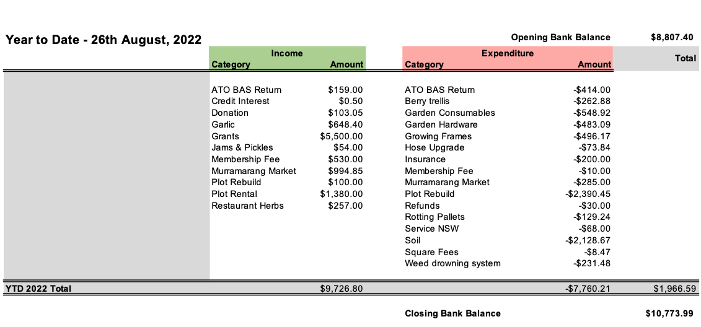
Appendix 2
