Choko & Cinnamon Loaf – with Walnuts

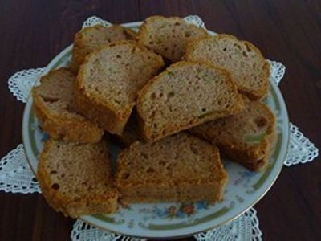 | - Ingredients  - 3 egg  - 1 tsp vanilla essence  - 1 cup peanut oil  - 3 cups plain flour  - 1 1/2 cups sugar  - 1 tsp salt  - 1 tsp carb soda  - 1/4 tsp baking powder  - 3 tsp ground cinnamon  - 2 cups chokoes peeled grated  - 1 cup walnuts chopped

Method:
Beat together eggs, oil and vanilla.
Add sugar and chokos, mix well.
Sift together flour, salt, cinnamon, carb soda and baking powder.
Fold egg and choko mixture into dry ingredients.
Add chopped walnuts and mix through.
Divide mixture between 2 lined or greased loaf pans.
Bake at 180C for 80 minutes or until cooked through.

