Murramarang Community Garden

Treasurers Report
Sunday 4th February 2024
- End of Year Financial Report ie. 31st December, 2023
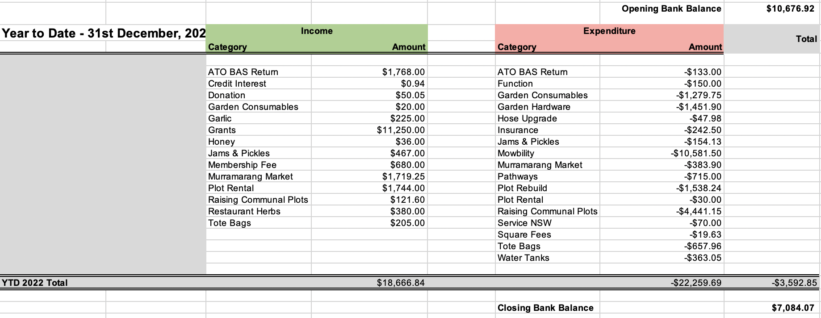
Regular Income / Expenses:
Income
Membership | $630
Plot Rental | $1,744
Honey, Jams & Pickles | $503
Markets & Garlic | $1,944
Restaurant Herbs | $380
Total | $5,201

Expenses
Garden Hardware | $1,452
Garden Consumables | $1,280
Insurance | $242
Total | $2,974

Key Projects Achieved
- Raising Communal Plots
Budgeted $6,101 final cost $6,261. Funded from Veolia Grant of $5,000 and remaining by the MCG. Nb. $1,660 was spent in 2022.

- Mowbility – Purchase of 2nd Ride-On Mower
Budgeted $12,000 final cost $10,582. Funded from FRRR – Foundation for Rural and Regional Renewal’s Grant of $10,000 and remaining by the MCG. Nb. We had a GST refund on the purchase of the mower for $954.

- Current Balance as at 31st January, 2024 $8,607.41
Vacant Member Plots | 9
Paid member Plots | 28
Outstanding member plots | 23
Number of paid members | 33
- Member List

The ‘master’ Member / Plot has been maintained. I need to update the board at the garden.

- Grants

In Progress

- NSW Government – The Communities Building Partnership 2023 CBP23
Application submitted 27th October, 2023 for our project ‘Enhancing Water Storage Capacity’ for $10,150. We will be informed of outcome in May, 2024.

- Foundation for Rural & Regional Renewal Round 7 – Mowbility $10,000
Final Report and Expenditure Declaration submitted 19th December, 2023. Waiting on review.

Potential

- Shoalhaven Council – Community Well Being.
Open now, for $2,000 - $5,000. closing 13th February, 2024

- Veolia – 2024 Round.
Open now, for $1,000 plus. Typical $5,000 - $20,000. Closing 21st February, 2024

- Community Bank South Coast – Pitch Perfect – A Community Funding Event
Open 17th May, 2024. Cate Wikner is the point of contact.

We need to identify projects to be undertaken as possible candidates for grant applications.
Some ideas:
Brightening our Solar
Tea Room Revamp
Others????

- Bunnings Sausage Sizzle

We ended up cancelling the sausage sizzle on the 25th November, as we didn’t have enough volunteers to run the BBQ.

